**2. DATA INGESTION**

**Part 2**

* 1. **1. Create the necessary structure in a MySQL database using the steps mentioned below: a. Create a new database in MySQL with the name *midproject***
  2. **Solution:**

**mysql -u edu_labuser -pedureka -h dbserver.edu.cloudlab.com**

**uselabuser_database**

**show tables; -- Permission denied inorder to create databases**

* + - 1. **b. Create a table in this database with the name *census_adult*to store the input dataset**

**Solution:**

**CREATE TABLE IF NOT EXISTS census_adult_1042728 (**

**age int**

**,workclass VARCHAR(50)**

**,fnlwgt int**

**,education VARCHAR(20)**

**,education_num int**

**,marital_status VARCHAR(20)**

**,occupation VARCHAR(50)**

**,relationship VARCHAR(50)**

**,race VARCHAR(50)**

**,sex VARCHAR(20)**

**,capital_gain int**

**,capital_loss int**

**,hours_per_week int**

**,native_country VARCHAR(50)**

**,income VARCHAR(10)**

**)**

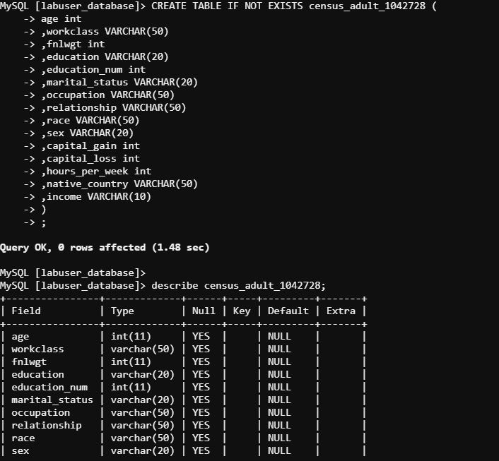

**c. Load the dataset into the table**

**LOAD DATA LOCAL INFILE '/mnt/home/edureka_702869/Mid_Term_Project-2/censusdata.csv' INTO TABLE census_adult_1042728 FIELDS TERMINATED BY ',' IGNORE 1 LINES;**

**d. Verify whether data is loaded properly**

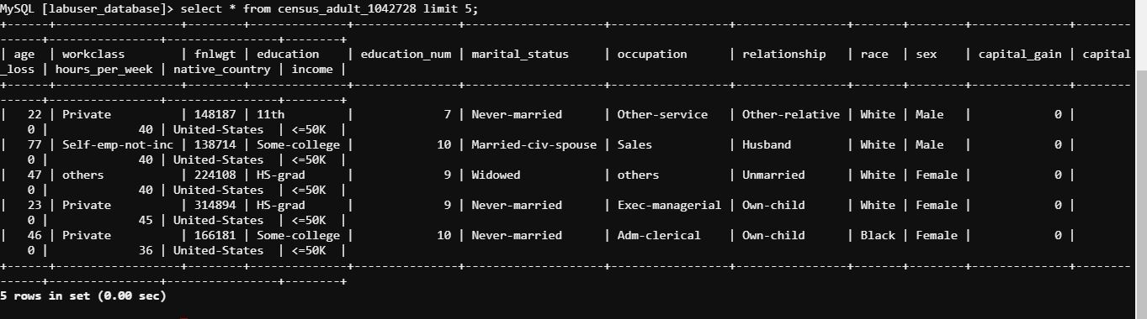

**e. Verify the table for unwanted data such as ‘?’,’Nan’ and ‘Null’**

* 1. **select 'workclass',count(1) from census_adult_1042728 where lower(workclass) in ('?','nan','null') union**
  2. **select 'occupation',count(1) from census_adult_1042728 where lower(occupation) in ('?','nan','null') union**
  3. **select 'native_country',count(1) from census_adult_1042728 where lower(native_country) in ('?','nan','null') union**
  4. **select 'education',count(1) from census_adult_1042728 where lower(education) in ('?','nan','null') union**
  5. **select 'marital_status',count(1) from census_adult_1042728 where lower(marital_status) in ('?','nan','null') union**
  6. **select 'relationship',count(1) from census_adult_1042728 where lower(relationship) in ('?','nan','null') union**
  7. **select 'race',count(1) from census_adult_1042728 where lower(race) in ('?','nan','null') union**
  8. **select 'sex',count(1) from census_adult_1042728 where lower(sex) in ('?','nan','null') union**

**select 'income',count(1) from census_adult_1042728 where lower(income) in ('?','nan','null');**

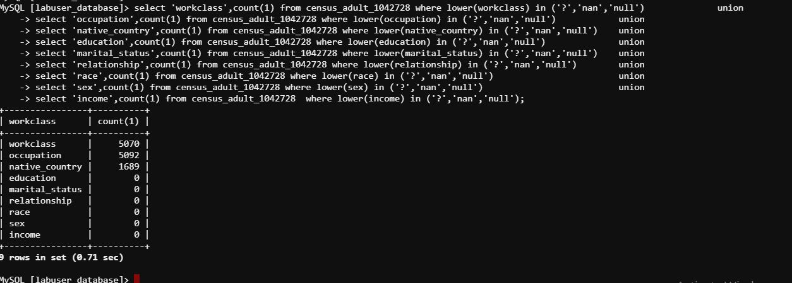

**f. Get the counts for the columns which contain unwanted data**

**select 'workclass',count(1) from census_adult_1042728 where lower(workclass) in ('?','nan','null') union**

**select 'occupation',count(1) from census_adult_1042728 where lower(occupation) in ('?','nan','null') union**

**select 'native_country',count(1) from census_adult_1042728 where lower(native_country) in ('?','nan','null')**

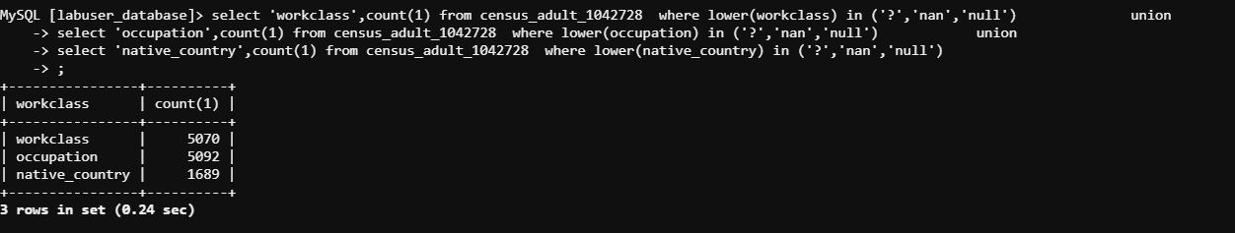

**g. Clean the data by replacing the unwanted data with *others***

**UPDATE census_adult_1042728 SET workclass = 'others' WHERE lower(workclass) in ('?','nan','null');**

**UPDATE census_adult_1042728 SET occupation = 'others' WHERE lower(occupation) in ('?','nan','null');**

**UPDATE census_adult_1042728 SET native_country = 'others' WHERE lower(native_country) in ('?','nan','null');**

**2. Import the above data from MySQL into a Hive table using Sqoop**

**sqoop import --connect jdbc:mysql://dbserver.edu.cloudlab.com/labuser_database --username edu_labuser --password edureka --table census_adult_1042728 --hive-import --create-hive-table --hive-table census_adult_hive1_edureka_1042728 --fields-terminated-by ',' -m 1 --target-dir /user/edureka_1042728/project2/pro_hive_1**

**3. Connect to PySpark using web console to access the created Hive table. Perform the following queries and note the time taken for execution in each of the queries.**

**from pyspark.context import SparkContext**

**from pyspark.sql import HiveContext**

**sqlContext = HiveContext(sc)**

**census_adult_hive = sqlContext.table("census_adult_hive1_edureka_1042728 ")**

**census_adult_hive.registerTempTable("census_adult_hive_temp")**

**from datetime import datetime**

**3.a. Query the table to get the number of adults based on income and gender**

**before_time = datetime.now()**

**sqlContext.sql("select income,sex,count(1) from census_adult_hive_temp group by income,sex").show()**

**after_time = datetime.now()**

**delta = after_time - before_time**

**time_in_seconds = delta.seconds + delta.microseconds/1E6**

**print("number of adults based on income and gender Time Taken: ",time_in_seconds)**

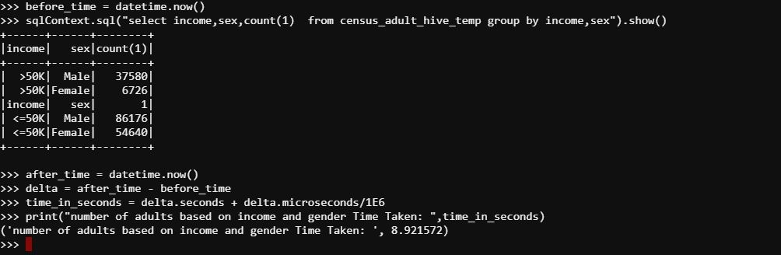

**3.b. Query the table to get the number of adults based on income and workclass**

**before_time = datetime.now()**

**sqlContext.sql("select income,workclass,count(1) from census_adult_hive_temp group by income,workclass").show()**

**after_time = datetime.now()**

**delta = after_time - before_time**

**time_in_seconds = delta.seconds + delta.microseconds/1E6**

**print("number of adults based on income and workclass Time Taken: ",time_in_seconds)**

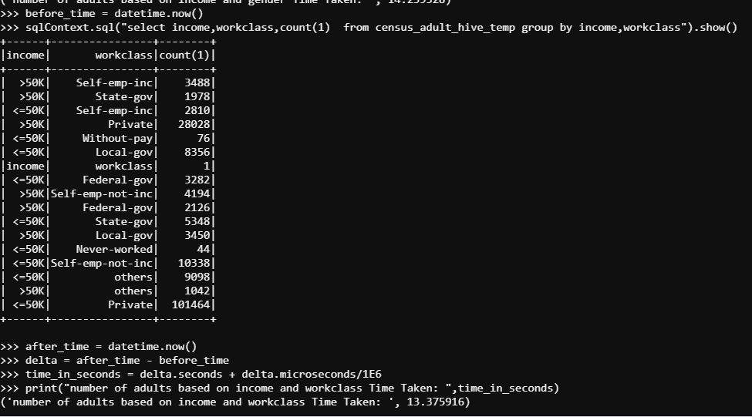

**4. Access the following two tables created as part of Problem 1 (HDFS and Hive) and perform the steps as mentioned below: a. Access Hive External Table with partition**

**Solution:**

1. **Query the table to get the number of adults based on income and gender**

**censusdata_partitioned_external = sqlContext.table("work_class_ext")**

**censusdata_partitioned_external.registerTempTable("censusdata_partitioned_external_temp")**

**before_time = datetime.now()**

**sqlContext.sql("select income,sex,count(1) from censusdata_partitioned_external_temp group by income,sex").show()**

**after_time = datetime.now()**

**delta = after_time - before_time**

**time_in_seconds = delta.seconds + delta.microseconds/1E6**

**print("censusdata_partitioned_external with income,sex Time Taken: ",time_in_seconds)**

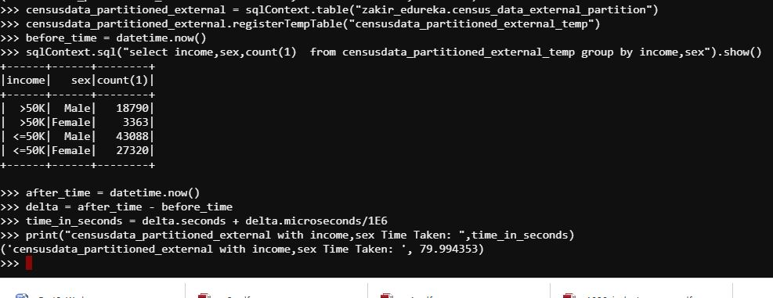

1. **Query the table to get the number of adults based on income and workclass**

**before_time = datetime.now()**

**sqlContext.sql("select income,workclass,count(1) from censusdata_partitioned_external_temp group by income,workclass").show()**

**after_time = datetime.now()**

**delta = after_time - before_time**

**time_in_seconds = delta.seconds + delta.microseconds/1E6**

**print("censusdata_partitioned_external with income,workclass Time Taken: ",time_in_seconds)**

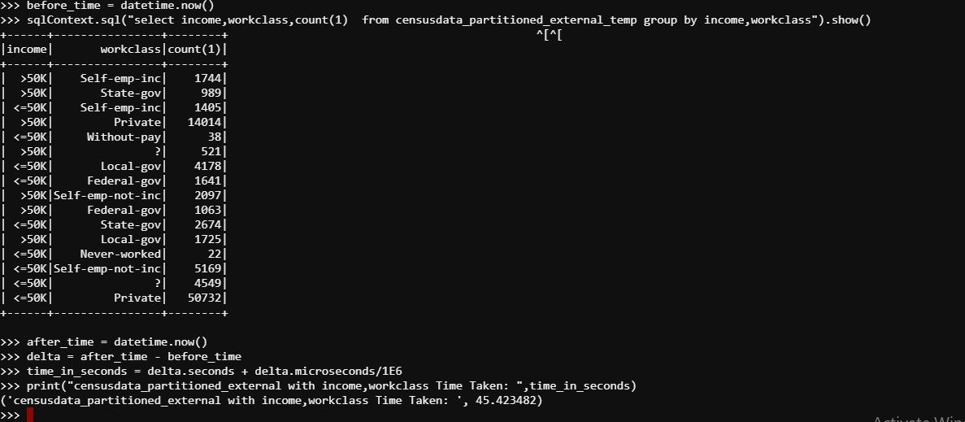

**b. Access Hive Internal Table with Partition**

**i. Query the table to get the number of adults based on income and gender**

**censusdata_partitioned = sqlContext.table("workclass1")**

**censusdata_partitioned.registerTempTable("censusdata_partitioned_temp")**

**before_time = datetime.now()**

**sqlContext.sql("select income,sex,count(1) from censusdata_partitioned_temp group by income,sex").show()**

**after_time = datetime.now()**

**delta = after_time - before_time**

**time_in_seconds = delta.seconds + delta.microseconds/1E6**

**print("censusdata_partitioned with income,sex Time Taken: ",time_in_seconds)**

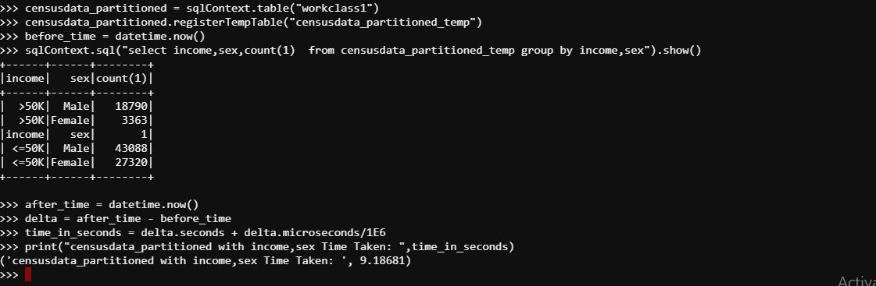

**ii. Query the table to get the number of adults based on income and workclass**

**before_time = datetime.now()**

**sqlContext.sql("select income,workclass,count(1) from censusdata_partitioned_temp group by income,workclass").show()**

**after_time = datetime.now()**

**delta = after_time - before_time**

**time_in_seconds = delta.seconds + delta.microseconds/1E6**

**print("censusdata_partitionedincome,workclass Time Taken: ",time_in_seconds)**

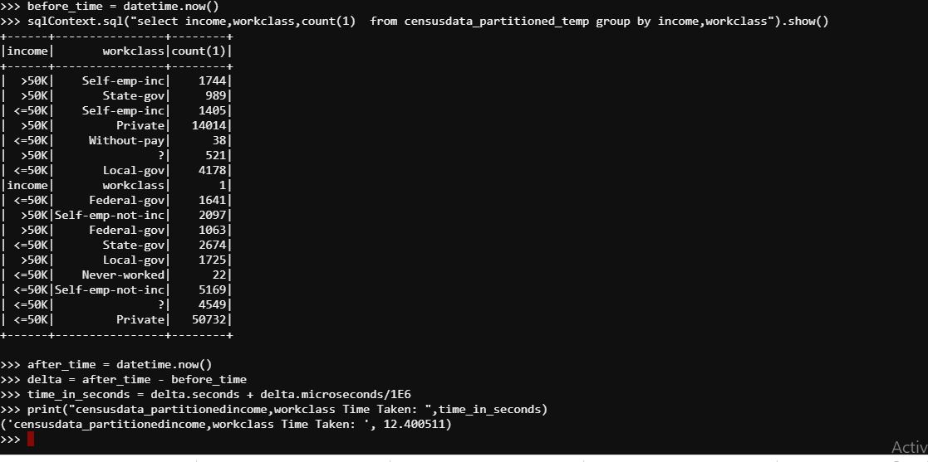

**5. Comment on the time taken for executing these commands using Spark as compared to the time taken for execution in Hive (Problem Statement 1).**

**Solution:**

|  |  |  |  |  |  |
| --- | --- | --- | --- | --- | --- |
| **Spark** | | | **Hive** | | |
| Table | 4 Row | 6 Row | Table | 4 Row | 6 Row |
| **census_adult_hive_edureka_702869** | 8.9 | 13.7 | **censusdata** | 24.25 | 21.77 |
| **census_data_external_partition** | 19.8 | 17.1 | **census_data_partition** | 34.54 | 26.28 |
| **census_data_partition** | 9.1 | 12.4 | **Census_data_external_partition** | 19.17 | 18.11 |